**MUN IMPORTANT DOCS :**

Prior to 2020, African countries were among the fastest growing in the world. The COVID-19 pandemic reversed decades of hard-won macroeconomic, socioeconomic and governance gains on the continent. For the first time in nearly three decades, Africa’s Human Development Index dropped. Millions of Africans lost their jobs; some 50 million were projected to be pushed into extreme poverty. Women and youth were hardest hit. The pandemic worsened financial and societal inequalities in Africa.In response to the pandemic, African countries put in place effective macroeconomic policies, made strategic investments and boosted COVID-19 vaccine production and rollout. By the end of 2021, Africa exceeded expectations of a 3.7 percent GDP growth, recording a 4.5 percent growth and showing its resilience and its muscle to bounce back. The continent seemed to come back in track.On February 24, Russia invaded Ukraine in an unprovoked act of aggression. The aftershocks of the ongoing war are being felt around the world, including in Africa.

1. A combination of the pandemic and the war in Ukraine has reduced trade and taxation revenues of governments across Africa, even as countries are being forced to spend on social safety nets. UNDP research shows that biased credit ratings could be costing six African countries $13 billion in additional interest rate payments and in addition to that Africa is borrowing at a much higher cost than the rest of the world. One of the most pernicious effects of the war in Ukraine is “imported inflation” & one such example is the case of Tanzania, where overall inflation spiked by 34 percent between February and April.
2. The war in Ukraine is a clear and present danger to multilateralism. Indication of this can be found in the fact that development projects are being postponed or cancelled. There are also signs of Africa’s development being defunded due to diversion of fund for humanitarian aids in Europe as a result of the war.

The AfCFTA(AFRICAN CONTINENTAL FREE TRADE AREA) provides an ideal framework for Africa to rationalize and harmonize tariffs, eliminate persistent non-tariff barriers and prioritize the uninhibited flow of trade and people among African countries. It could lift some 30 million Africans out of extreme poverty, by increasing income by $450 billion and more than double the size of the single Africa market to $6.7 trillion by the next decade. The United States could support the AfCFTA just as it has backed the European Union, which is the world’s largest single market area.

Africa needs to be more assertive about taking its rightful place in the world. Financial and global institutions should also understand that an investment in Africa’s well-being is an investment the world’s well-being.

1. The United States “has always looked at Africa as a partner, but sometimes it has not taken that partnership as seriously and as committedly as it should be,” Carson admitted. He said the United States should look for and frame policies that encourage Africa’s successful integration. That means working more effectively with regional and subregional organizations like the African Union, the Economic Community of West African States and the Southern African Development Community. Further, he said, there is a need to build relationships at the city-to-city and state-to-state levels as well.

The United States should also look at strengthening commercial ties with Africa. The creation of the U.S. International Development Finance Corporation has opened the possibility of U.S. government investment in African commercial business and development activities which is important as a partnership tool between US and AFRICA.

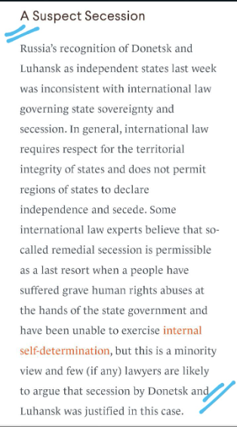

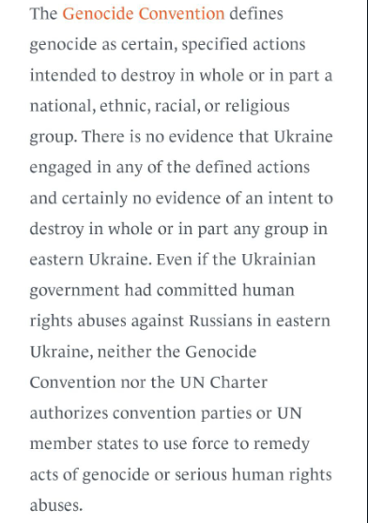

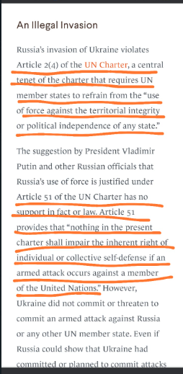

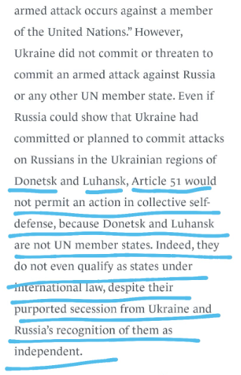

**This is important**  --- DONETSK and LUHANSK is the main two territory because of which the Ukraine -Russia war. It's the major illegal occupation by Russia. Ei duto place both countries claim as their own.

Tanzania is herself a weak country so donot charge any super power direct tomr country stance is neutral. So be that but because of them your agriculture and food is affected and also your economy is shattering so do point out the YOUR PROBLEM IN THE SPEECH.

Acha

**Possible solution can :**

Tanzania jodio kichu dite parena. But ota amk First day committee procedure ta brief koro shei analysis basis e will decide kono paper work thkbe ki kono block formation hobe kina.

And lastly, Afghanistan er delegate will try to lobby ( convience) you to recognize your country. DO NOT RECOGNISE AFGHANISTAN.

And you keep convincing the super power to veto jodi Afghanistan recognition chai.

UN4MUN e kono POI( point of information) hoina. So basically jodi karoke counter korar thake add that in your personal speech.

The Donetsk People's Republic and the Luhansk People's Republic are two Russian puppet states in the Donbas region of Ukraine. The two republics were proclaimed by Russian-backed separatists in 2014, who seized the areas by force and held internationally unrecognized status referendums shortly afterwards.

On February 21, Russia signed a Presidential Decree recognizing the "independence" of the "Donetsk People's Republic" and the "Luhansk People's Republic", as well as the "Treaty on Friendship, Cooperation and Mutual Assistance" granting the Russian Armed Force the right to build and use military bases and others.

**Russia says it now controls Ukraine's Luhansk region**, one of the two eastern regions that have been the focus of its invasion of Ukraine. The announcement comes after Ukrainian troops withdrew from Lysychansk, an industrial city that had become the last major Ukrainian-controlled holdout in the region

example from essaypro.com Smith 1 J. K. Smith Professor John Doe English 201 3 April 2022 Russia-Ukraine War 2022: Why Is There a War Between Russia and Ukraine? The backdrop of intense informational warfare makes it extremely difficult to discern the real reasons behind the war between Russia and Ukraine. It is safe to say that even those who are directly involved in this conflict would be unable to recognize the real reasons behind its start. The official statement from the Russian president Vladimir Putin cites the rising influences of nationalistic organizations as well as alleged discrimination against the Russian-speaking populace of Ukraine. While it’s clear these are just excuses for armed aggression, it’s as good of a place to start as any to uncover the real reasons for this tragedy. Russia-Ukraine War: How Did It Start? While many are limiting the scope of their analysis to the active phase of the Russian invasion of 2022, it’s important to go as far back as 2014 when the Ukrainian people forced the change in their pro-Russian government through the events of the Revolution of Dignity. Then the Russian military decided to make their move and occupy Ukrainian territories of the Crimean peninsula (Fisher par. 16). Initially, the soldiers wore no identifying clothing or insignia, and Russia denied any involvement. Vladimir Putin, afraid of losing influence in Ukraine and fearful of closer economic and military ties between Ukraine and the West, used the false pretext of protecting Russian-speaking people in Ukraine as an excuse to invade (David par. 13). example from essaypro.com Smith 2 Over the next few months, Russia established complete control over Crimea with little to no resistance. After that, Putin's government officially recognized Crimea as part of Russia despite the protests of the UN and the International Community (Fisher par. 14). Russia then focused its efforts on the regions of Donetsk and Luhansk in Eastern Ukraine, staging and financing an armed revolt against the local Ukrainian administration. Despite worldwide condemnation, Russia continued to supply and support the breakaway regions, fueling a slow-burning but violent conflict that has been going on for almost eight years. The Minsk agreements, seeking to end the war in East Ukraine, were installed to provide a period of peace (Fisher par. 25). Eventually, it was seen as both an attempt to bring some stability into the war-torn region and as a means to put political pressure on the Ukrainian government, by demanding concessions that would compromise its territorial integrity. Either way, the shaky peace has not lasted. example from essaypro.com Smith 3 When Did the Russian Invasion of Ukraine Start in 2022? War and constant reports of fighting in the East have become normal in Ukraine. Despite that, most people believed that an all-out Russian invasion would never happen. In early February 2022, American and European intelligence revealed that Russia was massing troops along its border with Ukraine ("Conflict In Ukraine" par. 2). NATO and other western powers accused Putin of escalating tensions and possibly planning an invasion, a claim that was outright denied. The people of Ukraine woke up on the 24th of February to the news that the Russian military had invaded in the middle of the night. A de-facto declaration of war was dubbed "a special military operation" by the Russian government. Among the stated goals of this military aggression were the "denazification" and "de-Ukrainisation" (Kirby, "Why Has Russia Invaded Ukraine" par. 9). The question of "Did Ukraine used to be a part of Russia?" wasn’t used in official sources. Yet Russian-controlled media is happy to use every opportunity to squeeze it in. example from essaypro.com Smith 4 Which Cities in Ukraine Suffered the Most? Two months of Russian occupation have devastated people, lives, and cities. Their military strikes have spanned the entire country reaching all the way to one of Ukraine's westernmost cities, Lviv. Russian forces have left a wake of destruction, including civilian casualties, mass graves, rape, torture, and other war crimes everywhere they have gone. Cities with tactical advantages have been targeted by the Russian invasion but Ukrainian resistance is strong. Kharkiv, Ukraine's second-largest city and a center for trade, education, and art, is located just 32km from the Russian border and was one of the first targets for the invaders. Kyiv, the beautiful capital city of Ukraine, successfully turned back enemy forces but only after seeing massive casualties sustained by the neighboring towns of Irpen and Bucha. Mariupol is still under the control of Russian forces, and the situation is quickly becoming a humanitarian crisis. Mariupol is located in the east, where Russia is now refocusing its efforts after failing in the rest of the country. Mariupol, as a port town, has vital strategic importance (Kirby, "Donbas" par. 4). Reports of Russian atrocities in the city include over 20,000 civilian casualties and the denial of refugee corridors. Ukrainian Refugees: How Did the Life of Ukrainian People Change When the War Began? Not only is their country being invaded and destroyed, but over a quarter of Ukraine's 44 million population has been displaced, leaving behind homes, treasured possessions, and family members. Over six million Ukrainians, mostly from the East, have fled their cities to find refuge in the west of the country with whatever they can carry. Migration on this scale would have been a horrendous humanitarian disaster if not for the swift help of the people and governments of neighboring countries. Many of Ukraine’s western example from essaypro.com Smith 5 partners have done a lot to accommodate the influx of refugees and provide them with decent living conditions until they are able to return to their homes. The diplomatic effort of the Ukrainian president has played a major role in this. According to The Operational Data Portal, European countries took in 5.56 million refugees ("Ukraine Refugee Situation"). ● Poland has welcomed over 3 million Ukrainians into the country. ● Romania has taken in 825,840 people displaced by war. ● Approximately half a million people have entered Russia because of family ties. ● Half a million Ukrainians have found refuge in Hungary. ● The Republic of Moldova now houses 447,600 Ukrainians. ● Slovakia has accepted 379,450 Ukrainians so far. Furthermore, the EU has passed a bill to allow Ukrainians to live and work within their territories for three years, and many governments have opened community shelters and other programs for Ukrainian refugees. Russo-Ukrainian War: Statistics It is difficult to put a number on the human pain, loss, and suffering, but the raw statistics for the War in Ukraine are indeed appalling. According to The OHCHR, 2,729 civilians have died in the last two months (among them 201 children) and 3,111 civilians were injured ("Ukraine: Civilian Casualty Update" pars. 2-3). Although, the OHCHR admits the real number is probably much higher. Other data claims that ● 15000 Ukrainians have been reported missing in the last two months; ● 11 million Ukrainians are displaced, with 5 million becoming international refugees; example from essaypro.com Smith 6 ● reports vary, but over 100 billion dollars of property damage has occurred; ● over five hundred billion dollars of economic damage was done; ● more than 50 historical sites have been damaged ("War With Russia: More Than 15,000 People Already Missing In Ukraine"). How Does Ukraine's President Volodymyr Zelensky Act? Ukraine's President Volodymyr Zelensky has impressed his own people, citizens around the world, and government leaders with his bravery and impassioned appeals for assistance. He has defied Putin, reached out to allies, and called out government leaders and countries slow to criticize Russia, all the while staying in Kyiv with his people. His diplomatic efforts as well as his refusal to leave Kyiv, have had a tremendous effect on the people of Ukraine. He wasn’t awfully popular during peacetime but has risen to his station during this time of crisis, doing everything to help out his country has inspired Ukrainians. This has meant that today, even his example from essaypro.com Smith 7 opponents are rallying behind him. Whether this will last after the war is over is yet to be seen, but for now, he remains the hero Ukrainians need. Ukraine Now: Did Ukraine Take Down the Russian Ship? The Russian warship Moskva, the flagship of Russia's Black Sea Fleet, was hit and sunk by Ukrainian forces using Neptune missiles. Russia claims that the ship sank because of an accident, but this is an attempt to deny Ukraine this victory (Schreck par. 6). Although it’s a largely symbolic event, its significance can’t be overstated. It is a humiliating defeat for the Russian military as well as a great example of the Russian disinformation machine at work. Current Ukraine news highlights both of these points. There are multiple angles to this event that could be approached from. This makes it a prime candidate for an essay thesis or topic. Conclusion The implications of this conflict are colossal. The geopolitical consequences of a failed invasion will set Russia back in terms of its influence in the region. Economic damage to both sides will have devastating effects on a global scale. Some of them can be felt even now, with inflation and goods deficits rising across the globe. The damage to Russian political standing in the global arena has been all but apocalyptic. It will be decades before they are able to recover even a fraction of their ties with western powers. Countries that share their borders with the aggressor are suddenly very concerned with their security and the alliance has multiple new members waiting in line to join the umbrella of collective protection. example from essaypro.com Smith 8 Works Cited "Conflict In Ukraine." Council On Foreign Relations, 29 Apr. 2022, www.cfr.org/global-conflict-tracker/conflict/conflict-ukraine. "Ukraine: Civilian Casualty Update." Office of the High Commissioner for Human Rights, 26 April 2022, https://www.ohchr.org/en/news/2022/04/ukraine-civilian-casualty-update-26-april-202. Accessed 2 May 2022. "Ukraine Refugee Situation." The Operational Data Portal, data2.unhcr.org/en/situations/ukraine. Accessed 2 May 2022. "War With Russia: More Than 15,000 People Already Missing In Ukraine." Ukrinform, 9 Apr. 2022, www.ukrinform.net/rubric-society/3453124-war-with-russia-more-than-15000-people-a lready-missing-in-ukraine.html. David, Kathryn. "Why Did Russia Invade Ukraine?" The Conversation, 7 Mar. 2022, theconversation.com/why-did-russia-invade-ukraine-178512. Fisher, Max. "Everything You Need To Know About The 2014 Ukraine Crisis." Vox, 3 Sep 2014, www.vox.com/2014/9/3/18088560/ukraine-everything-you-need-to-know. Kirby, Paul. "Donbas: Why Russia Is Trying To Encircle Ukraine’s East." BBC News, 19 Apr. 2022, www.bbc.com/news/world-europe-60938544. Kirby, Paul. "Why Has Russia Invaded Ukraine And What Does Putin Want?" BBC News, 30 Apr. 2022, www.bbc.com/news/world-europe-56720589. example from essaypro.com Smith 9 Schreck, Adam. “Russia’s Damaged Black Sea Flagship Sinks in Latest Setback” The Associated Press, 15 Apr. 2022, apnews.com/article/russia-ukraine-zelenskyy-kyiv-black-sea-estonia-8ccaa918f813a84 4321187ed116ff091